Algebraic Expressions
An algebraic expression is a branch of Mathematics made up of variables and constants along with operations(addition, subtraction, etc.)
Expressions are made up of terms.
Example of algebraic expression:
3x+4y -7, 4×3-10 etc.
It is to be noted that, an expression has no sides or equal to sign, just like in algebraic equation.
The terminology used in Algebraic expressions:
In Algebra we work with Variable, Symbols or Letters whose value is unknown to us.
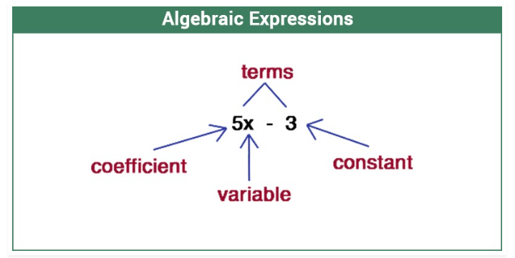

In the above expression, x is a Variable, whose value is unknown to us which can take any value.
5 is known as Coefficient of x, as it is a constant value used with the variable term and is well defined.
3 is the Constant value term which has a definite value.
The whole expression is known to be the Binomial term, as it has two unlikely terms.

